Habiba Yehia Aboraya

211002226

Database Project

Project: **PharmacyDB**

**Description Overview:**

PharmacyDB is a comprehensive relational database system designed to manage and facilitate the operations of pharmacies. It integrates various entities such as pharmacies, patients, drugs, suppliers, employees, and more into a cohesive framework. This system supports tracking of drug inventory, supplier details, patient drug history, and employee records, thereby enhancing the efficiency of pharmacy management.

**Schema:**

1. **Pharmacy:** Phone (Primary Key), Address, Name.

2. **Patient:** ID (Primary Key), Address, Name, Phone.

3. **Supplier:** Name (Primary Key), Address.

4. **Drug:** Name (Primary Key), Price, Expiry Date, Quantity, Ingredients, Purpose, Supplier_Name (Foreign Key).

5. **Employee:** ID (Primary Key), Name, Address, Job Title, Pharmacy_Phone (Foreign Key).

8. **Pharmacy_Drug (Many-to-Many Relationship):** Pharmacy Phone, Drug Name **(**Composite Key**).**

9. **Patient_Drug (Many-to-Many Relationship):** Patient_ID, Drug_Name **(**Composite Key**).**

Employee

Work

Made

Patient

Buy

Sell

Supplier

Pharmacy

Drug

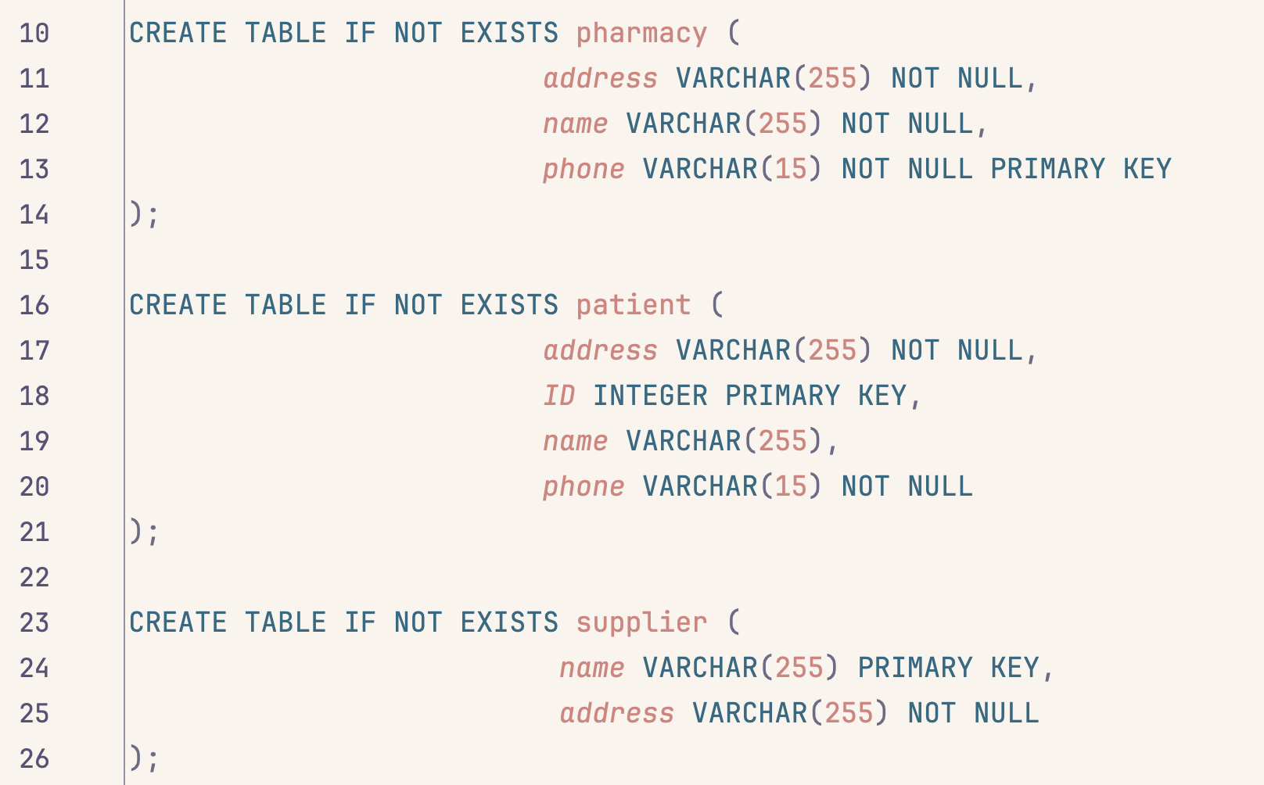Create Table Statements:

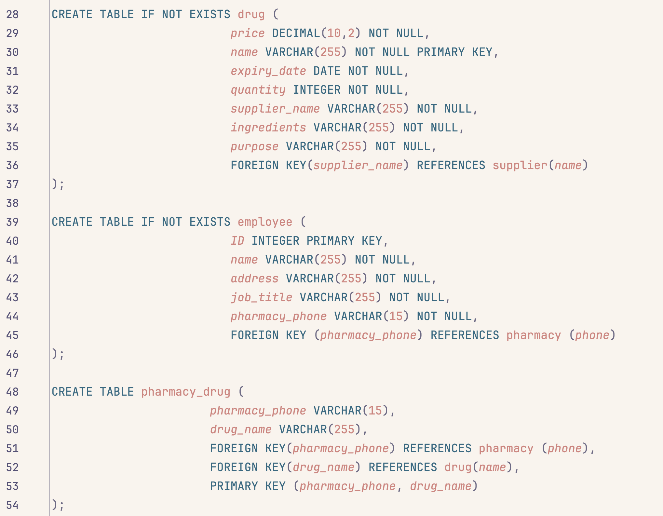

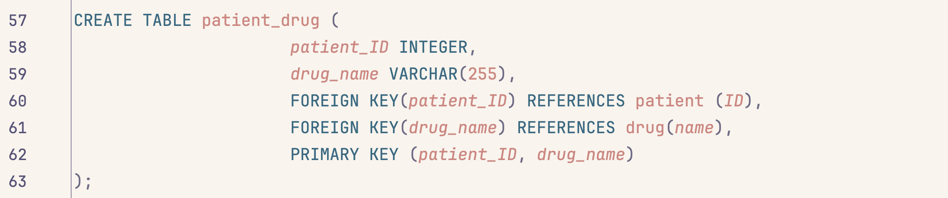

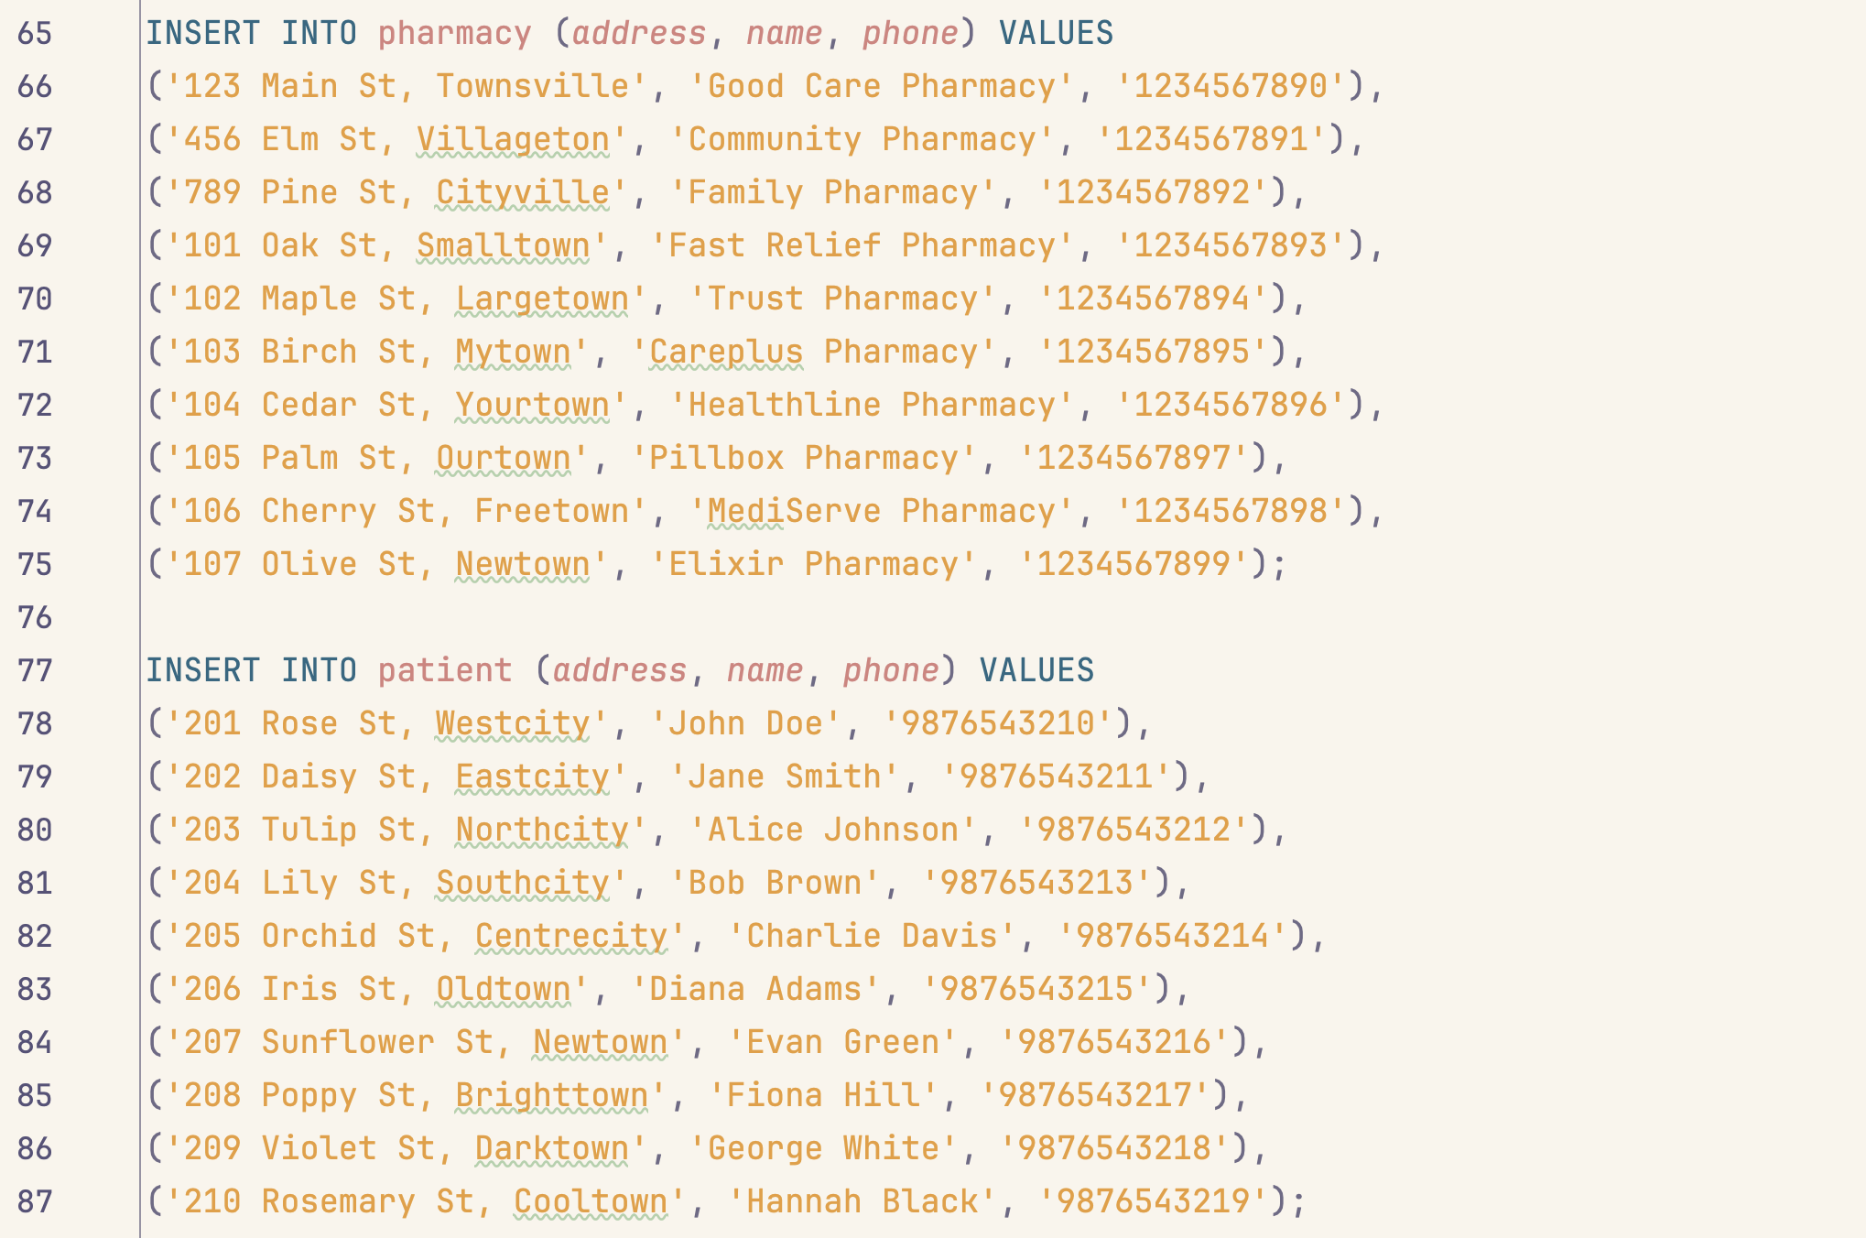Insert Statements:

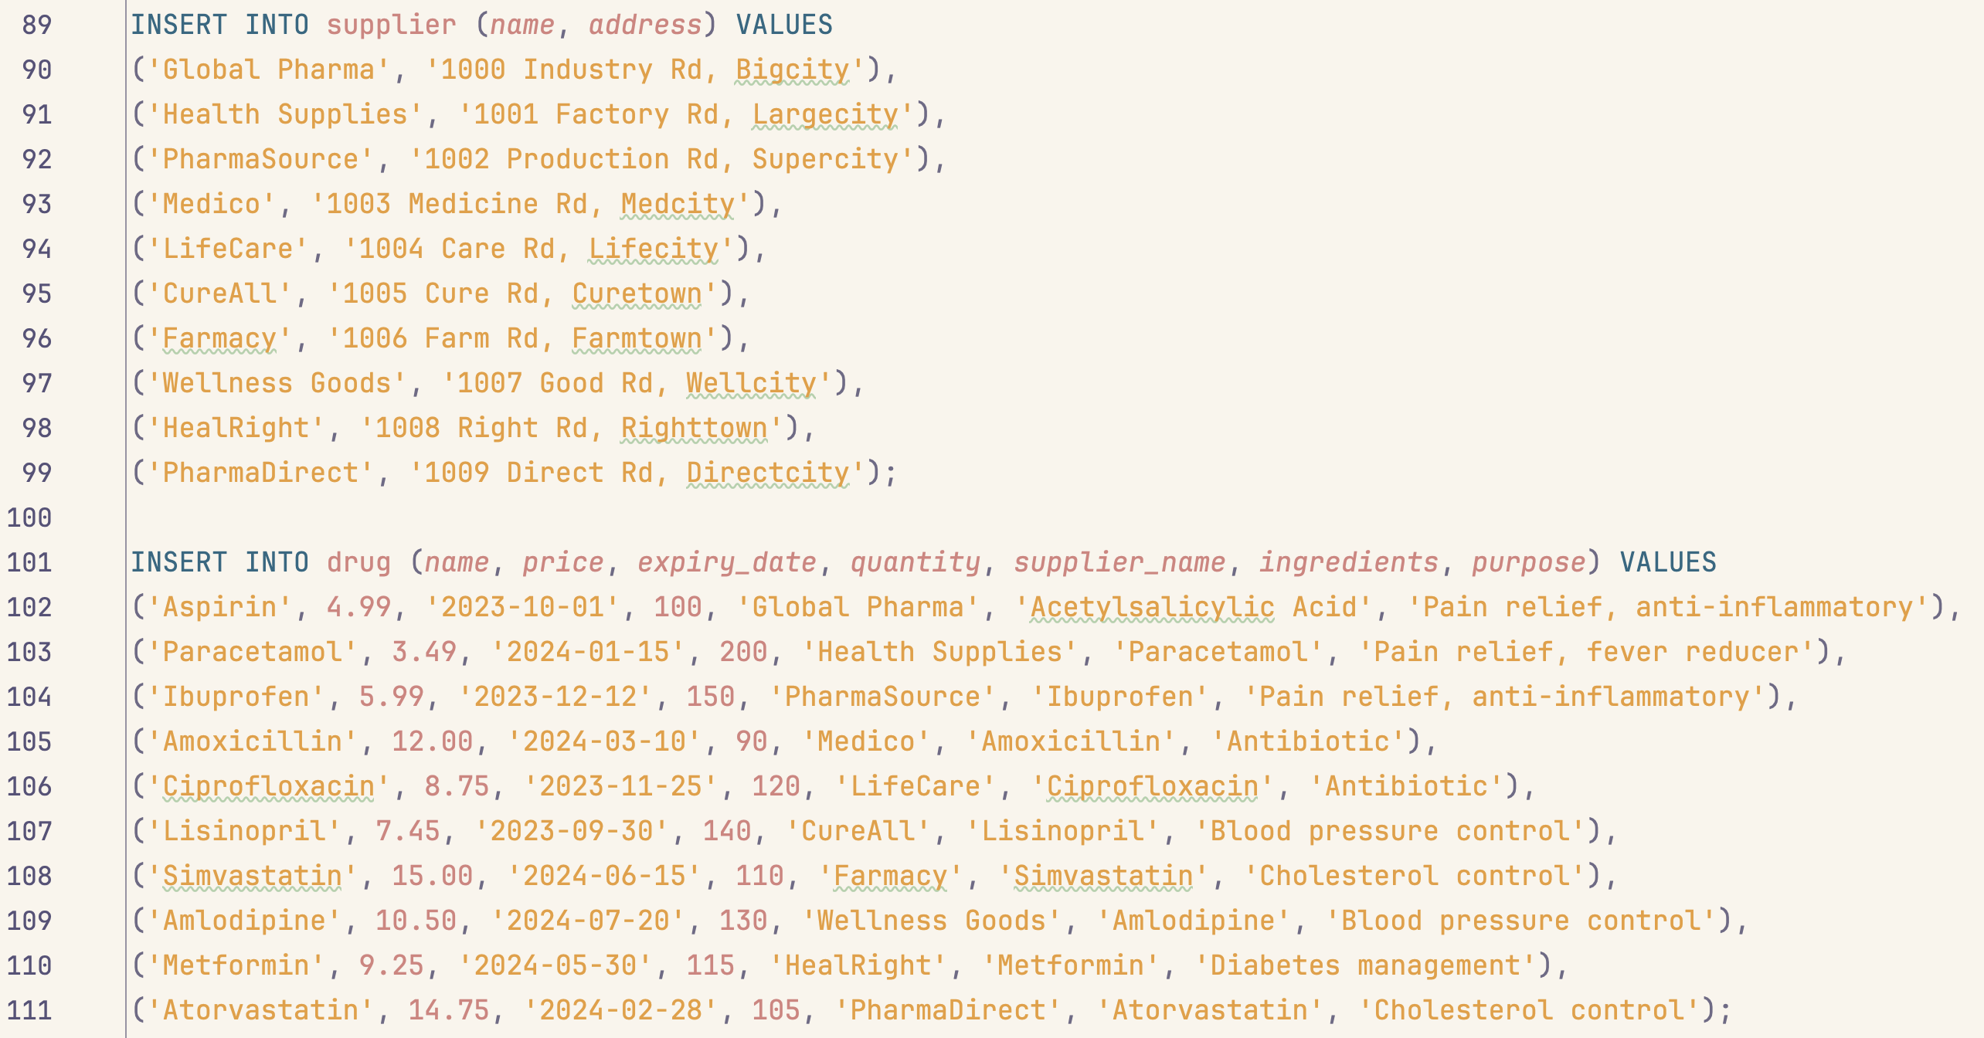

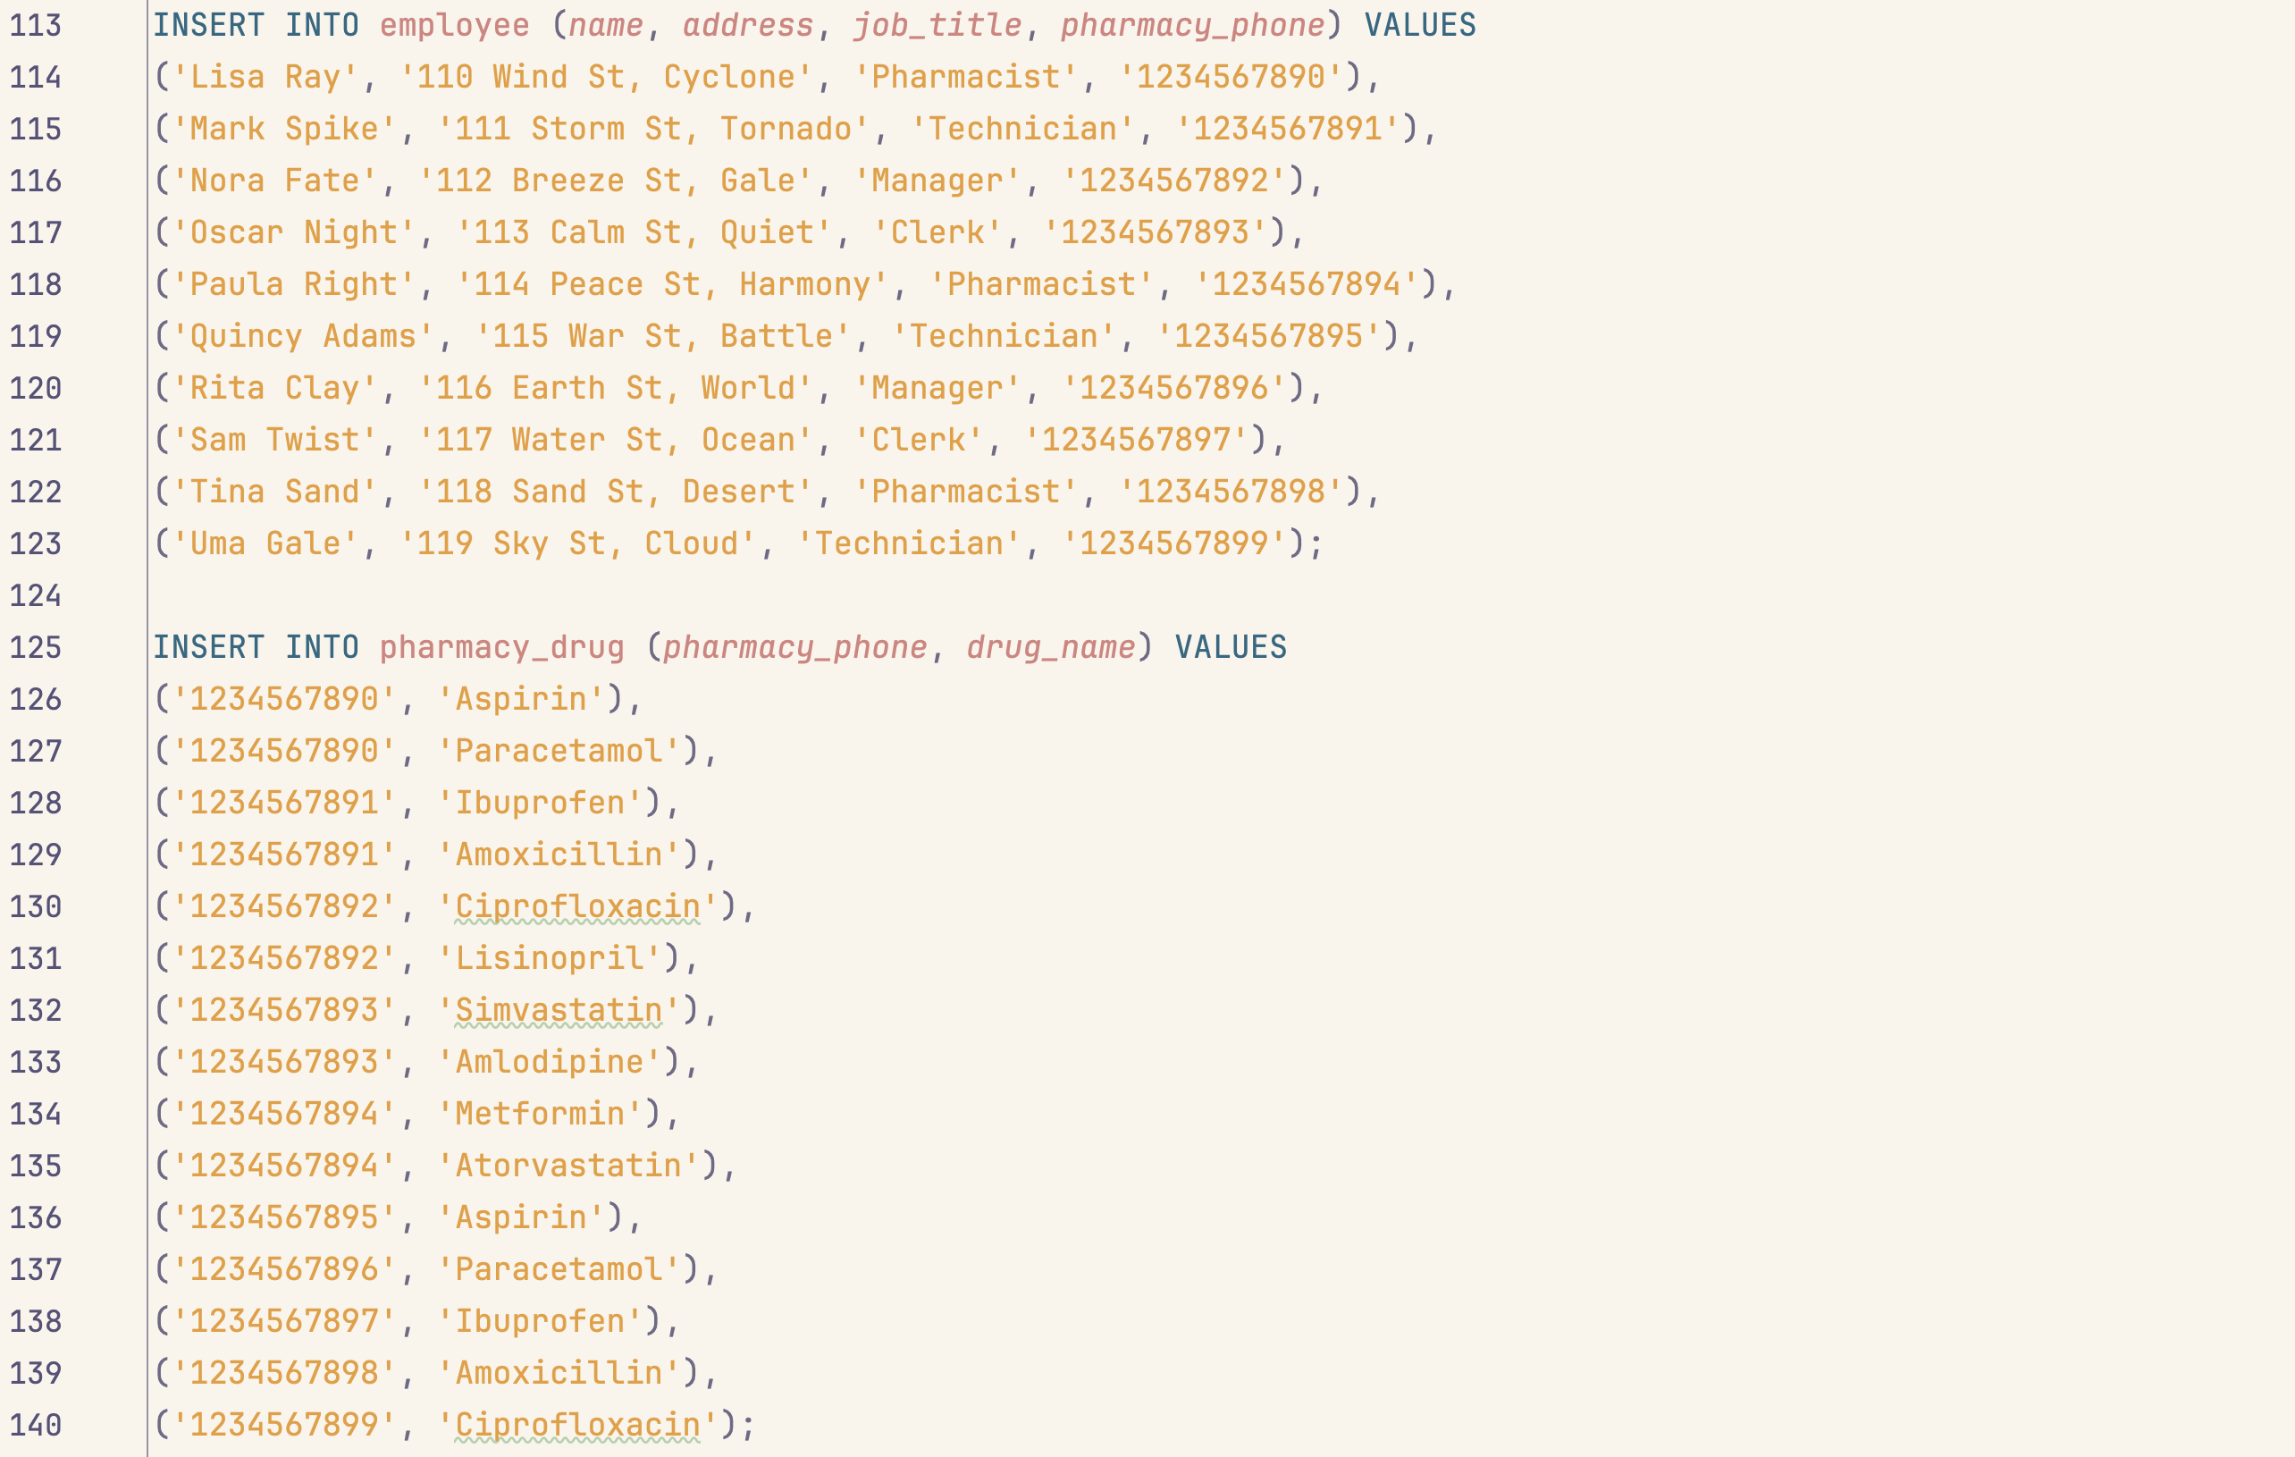

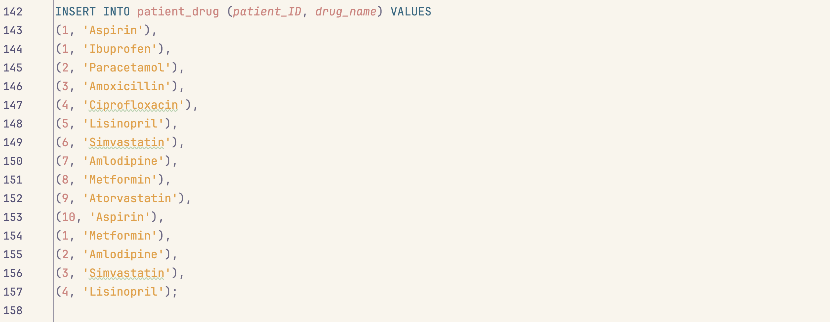

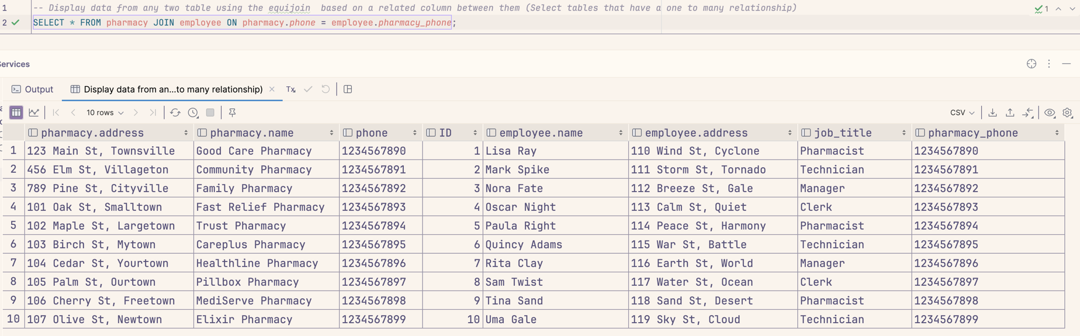Display data from any two table using the equijoin based on a related column between them (Select tables that have a one-to-many relationship):

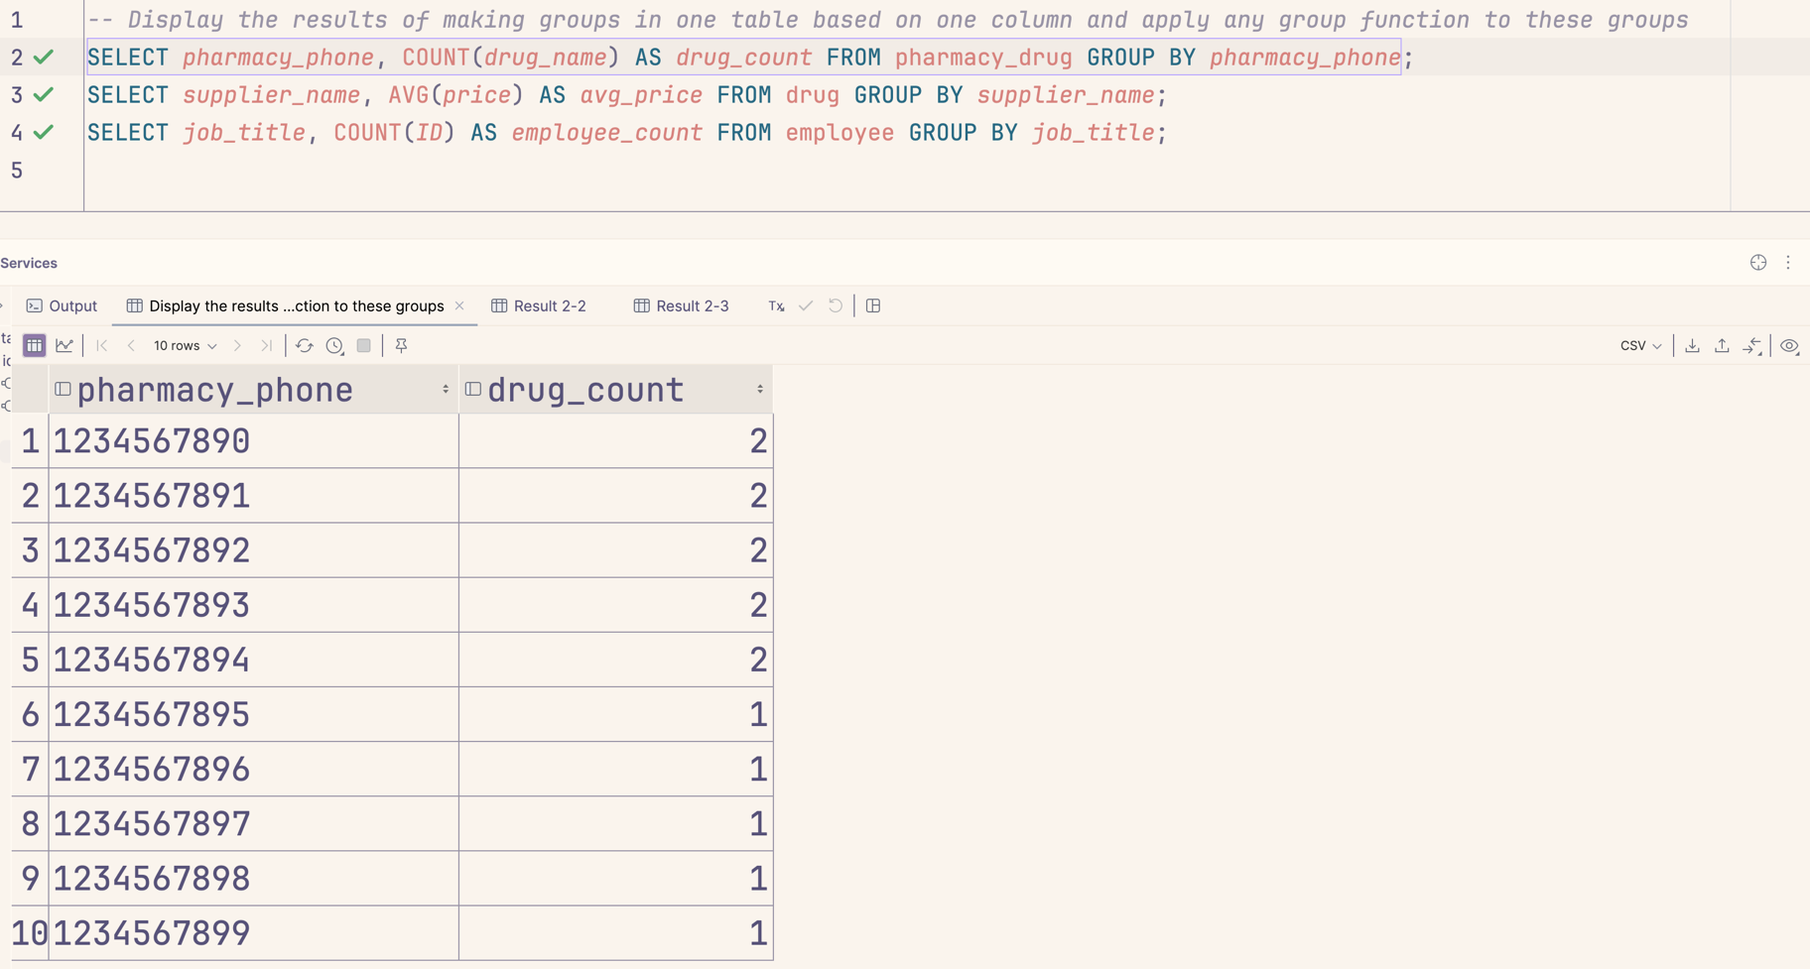Display the results of making groups in one table based on one column and apply any group function to these groups:

